**COMPUTER PROGRAMMING**

**LAB TASK NO# 07**

**OPEN-ENDED LAB**



**NAME: IQRA HAFEEZ.**

**ENROLLMENT NO: 01-131232-036**

**CLASS: BSE 1(B)**

**DEPARTMENT OF SOFTWARE ENGINEERING,**

**BAHRIA UNIVERSITY ISLAMABAD.**

**COMPUTER PROGRAMMING**

**CP LAB TASK# 07**

**OPEN ENDED LAB**

**TASK NO# 01**

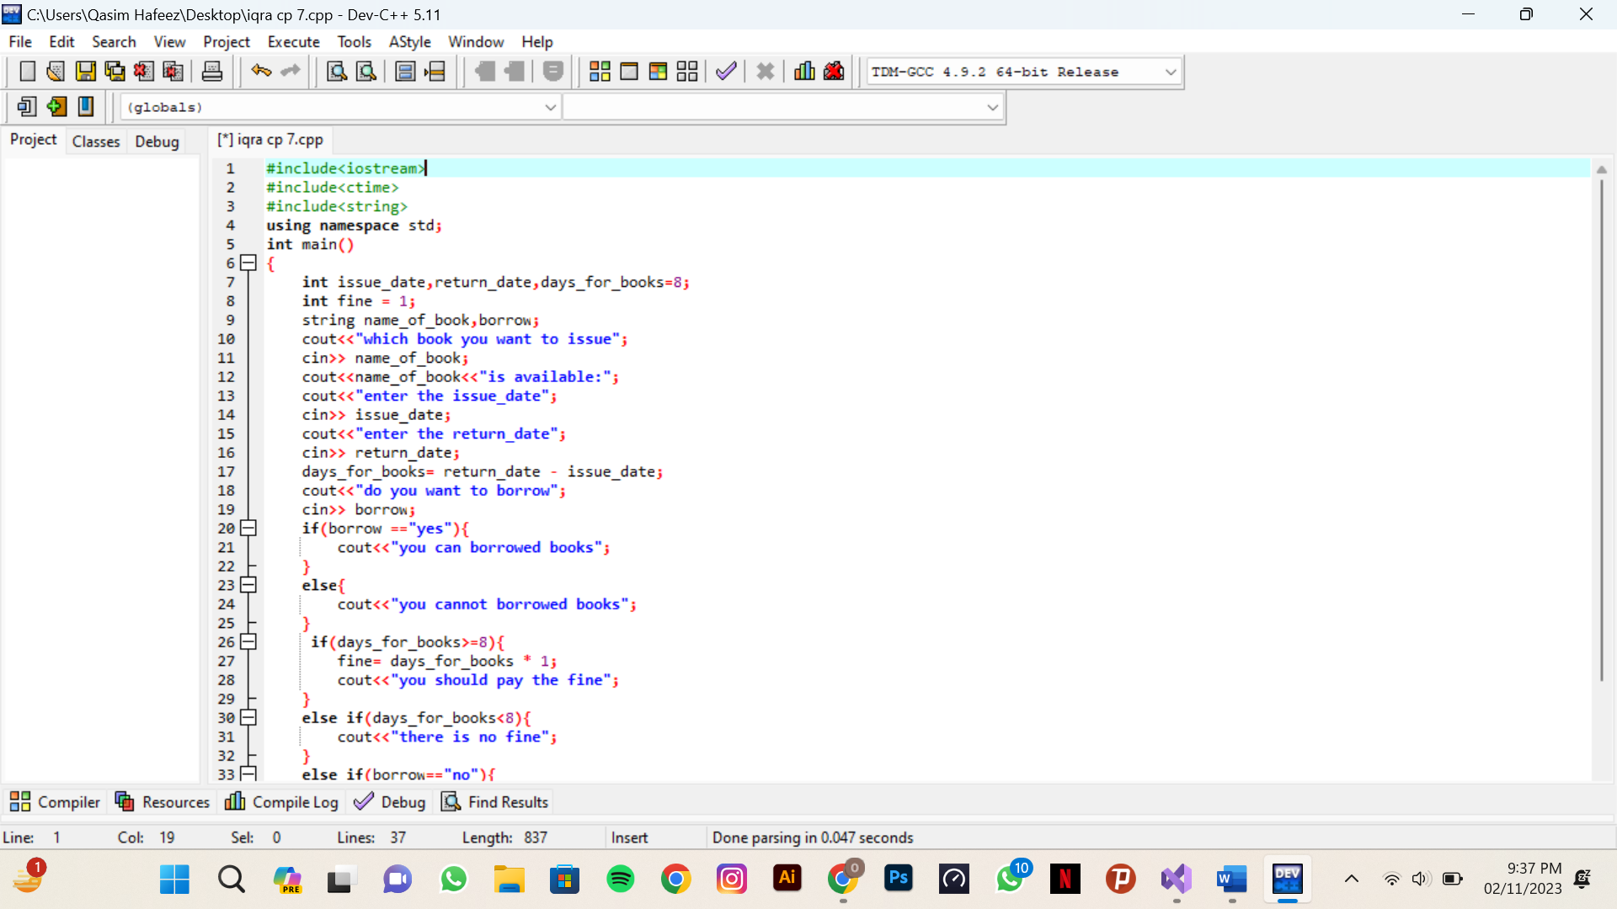

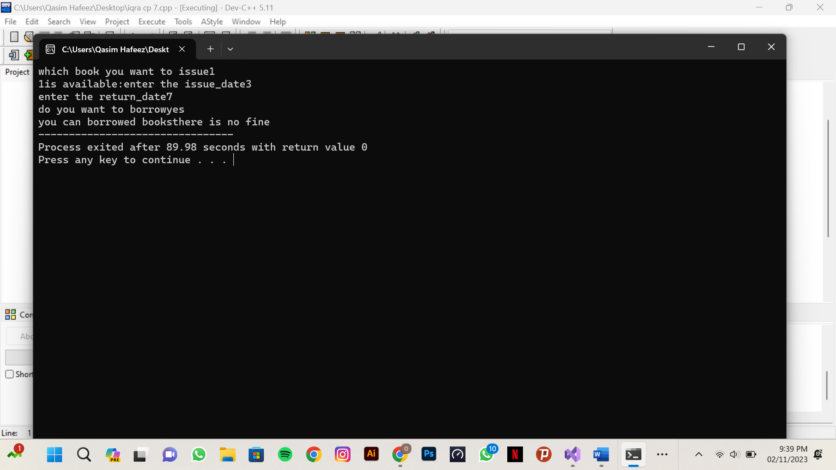

**TASK NO# 02**



